Vihari Gardens -4

Please attach Site photos from google map
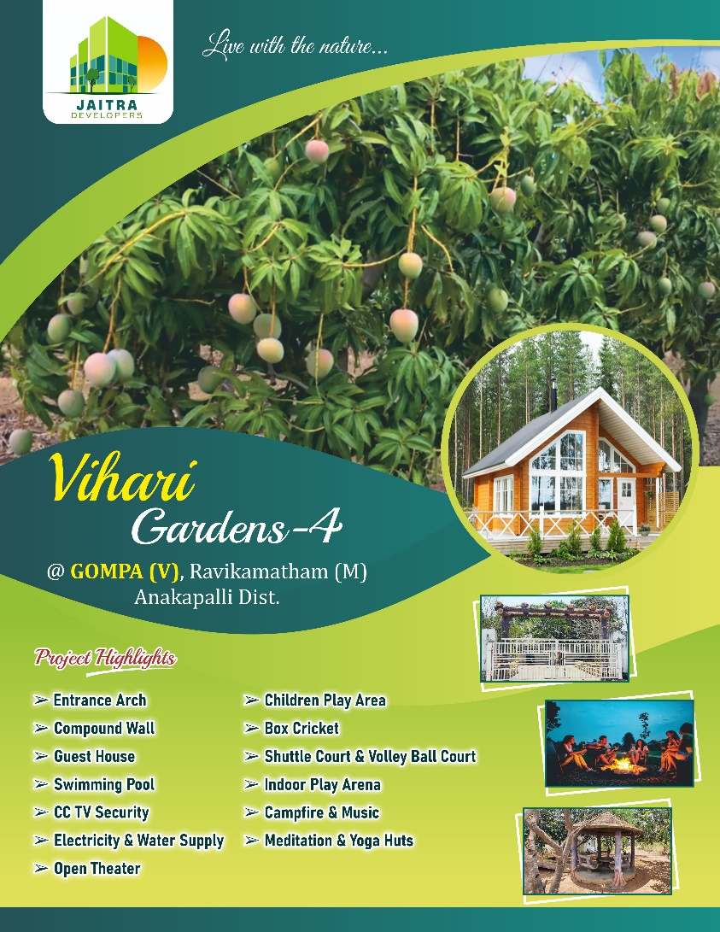


Attach LAYOUT COPY here
Layout copy should be displayed and downloadable

Project Amenities & Developments
- Red sandal and mango Plantation project situated at Gompa near Thattabandha, Ravikamatam mandal in Anakapalli District.
- Plots sizes starting from 100 Sq yards and all plots area as per Vastu
- Best plot size of 20’ X 45’ (suitable for individual residential building construction)
- Free Maintenance of farm lands
- All Gravel roads
- Entrance Arch
- Compound Wall
- Guest House
- Swimming Pool
- CCTV Security
- Electricity & Water Supply
- Open Theatre
- Children Play Area
- Box Cricket
- Shuttle Court & Volley Ball Court
- Indoor Play Arena
- Campfire & Music
- Meditation & Yoga Huts

Benefits of Investing
- Project situated about 45 kms from Gajuwaka and just 4km from Ravikamatham Mandal Head Quarter.
- RTC Bus Available for Every 30mins from Site
- Minimum 3 days stay at farm land in a year for the customer holding a minimum of 200 Sq yards stay increases in proportion to land holding.
- Project facing 40 feet R&B road connecting from Thattabandha to Ravikamatham
- Project is just adjacent to residential area and suitable for individual Residential building construction and best suitable for Resorts.
- All the primary amenities i.e., School, Hospital, Grama sachivalayam, Raithu barosa Kendram are hardly at a distance to 300metres from the project location
- Project is located at the core area which is nearer to all the major areas i.e., Anakapalle NH, Thallapalem NH, Ravikamatam Mandal Head Quarter
- Investment with very good scope of returns.
- A good investment option for guaranteed future returns.

Site Address & Location
- Vihari Gardends-4, Gompa Village, near Thattabandha, Ravikamatam (Mandal), Anakapalle(Dist), Andhra Pradesh.
- jaitradevelopers@gmail.com
Google Site location: https://maps.app.goo.gl/oYWdfK56BMwfoeEE8

